**Lab Report 2**

## **Aim**

Using Discrete Fourier Transform (DFT) to analyse images and operate various filters on them.

## **Theory**

##### The two-dimensional discrete Fourier transform (DFT) of an image f(x,y) of size M x N is represented by:

C:\Users\mypc\Desktop\Sparse\DIP\DIP_15EC4110\Labs\New folder\Lab5\Frequency Domain Processing_files\DFT.gif

##### The corresponding inverse of the above discrete Fourier transform is given by the following equation

##### C:\Users\mypc\Desktop\Sparse\DIP\DIP_15EC4110\Labs\New folder\Lab5\Frequency Domain Processing_files\InvDFT.gif

* The magnitude and phase spectrum of an image f (x, y) is represented by

**

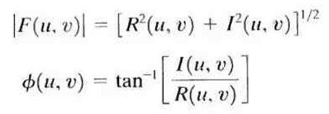

* where R(u, v) and I(u, v) are the real and imaginary components of the spectrum F(u, v). Similarly, the power spectrum is represented by

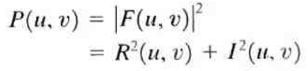

**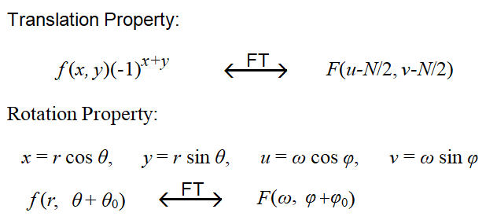**

* We use *fft2()* and *fftshift()* for DFT and it’s translation property respectively

##### **CODE**

% Spectrum of an image

% Create an image with a white rectangle and black background.

clear; close all; clc;

% Generate an image

im = zeros(30,30);

%%

im(5:24,13:17)=1;

%%

figure();

imshow(im); title('Original Image'); axis on

%%

% display('Spectrum of the image');

% display('Press any Key');

% pause

% Find the Spectrum using FFT

imF = fft2(im);

%%

imF\_mag = abs(imF);

figure(); imshow(imF\_mag,[]);title('Magnitude Spectrum'); axis on

%%

% display('Spectrum of the image with fftshift');

% display('Press any Key');

%

% pause

% The zero-frequency coefficient is displayed in the upper left hand corner.

% To display it in the center, you can use the function fftshift.

imF\_mag = fftshift(imF);

imF\_mag = abs(imF\_mag);

figure(); imshow(imF\_mag,[]);title('Magnitude Spectrum with fftshift'); axis on

%%

% display('Spectrum of the image with zero padding');

% display('Press any Key');

% pause

% To create a finer sampling of the Fourier transform,

% you can add zero padding to im when computing its DFT.

imF=fft2(im, 256,256);

imF\_mag = abs(fftshift(imF));

figure(); imshow(imF\_mag,[]); title('Magnitude Spectrum with Zero padding'); axis on

%%

% display('Spectrum of the image with log magnitude');

% display('Press any Key');

% pause

% To brighten the display, you can use a log function

imF\_log\_mag=log(1+imF\_mag);

figure,imshow(imF\_log\_mag,[]);title('Log Magnitude Spectrum'); axis on

disp('End of the program');

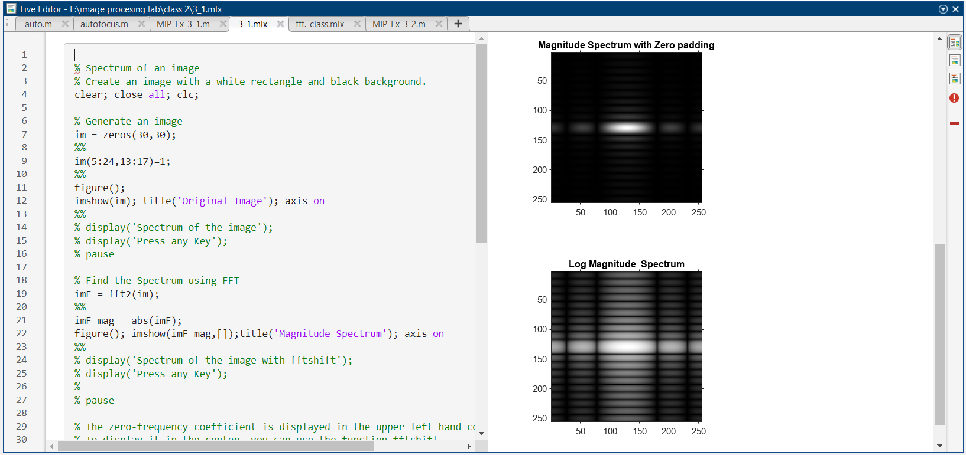

Figure 1: use of fft2( ) and fftshift( ) function in MATLAB

##### **CODE**

% Example 2: Spectrum and reconstruction of an image with magnitude and

% phase spectrums

clear; close all; clc;

a=zeros(256,256);

a(78:178,78:178)=1;

figure();

subplot(2,2,1); imshow(a);title('Original Image'); axis on;

%%

af=fftshift(fft2(a));

subplot(2,2,2);imshow(abs(af));title('Spectrum of Image');

%%

% Now rotated the image by 45 degrees

[x,y] = meshgrid(1:256,1:256);

b=(x+y<329)&(x+y>182)&(x-y>-67)&(x-y<73);

subplot(2,2,3);imshow(b);title('Rotated Image');axis on;

%%

bf = abs(fftshift(fft2(b)));

subplot(2,2,4);imshow(bf);title('Spectrum of Rotated Image');

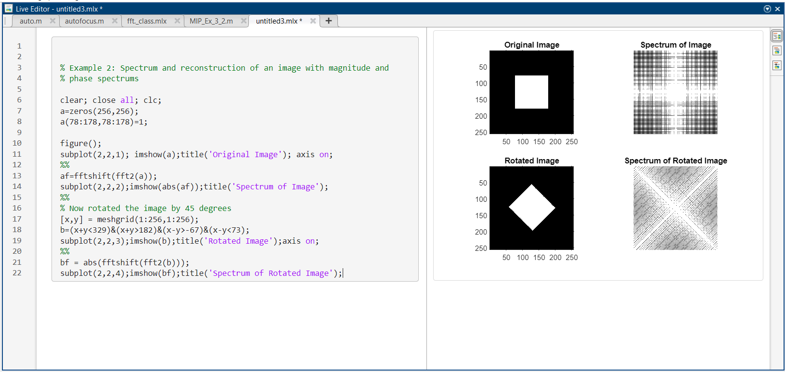

Figure 2: use of fft2( ) and fftshift( ) function in MATLAB

##### **CODE**

% Example 3 % Explore the FFT of an image

clear;close all;clc;

im = imread('hand-x-ray.jpg');

[m n] = size(im);

%%

% Spectrum calculations

imF = fft2(im); % 2D FFT

imF\_mag = abs(imF); % Magnitude Spectrum

s = log(1+abs(fftshift(imF)));% Log Magnitude Spectrum

imF\_ph=angle(imF); % Phase Spectrum

figure();

subplot(1,3,1); imshow(im); title('Original Image');

subplot(1,3,2); imshow(s,[]); title('Log Magnitude Spectrum');

subplot(1,3,3); imshow(imF\_ph); title('Phase Spectrum Image');

%%

% Reconstruction

% Reconstruction by combining both magnitude and phase spectrum

imr = ifft2(imF\_mag.\*exp(1i\*imF\_ph))/(m\*n);

%%

% Reconstruction by only magnitude spectrum

imr\_mag = abs(ifftshift(ifft2(imF\_mag)));

% imr\_mag = abs((ifft2(imF\_mag)));

% Reconstruction by only phase spectrum

imr\_ph = ifft2(exp(1i\*imF\_ph))/(m\*n);

figure();

subplot(1,3,1); imshow(imr,[]); title('Recon. Magn and Phase');

subplot(1,3,2); imshow(uint8(imr\_mag),[]); title('Recon.with Mag Spectrum only');

subplot(1,3,3); imshow(imr\_ph,[]);title('Reconstruction with Phase Spectrum only');

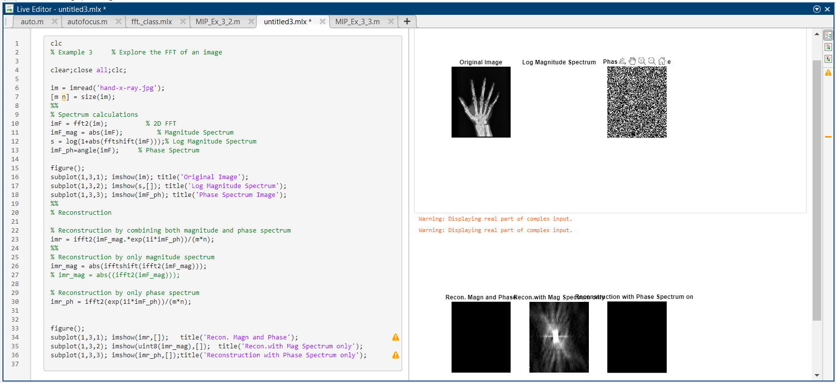

Figure 3: use of fft2( ) and fftshift( ) function in MATLAB

## **Exercise**

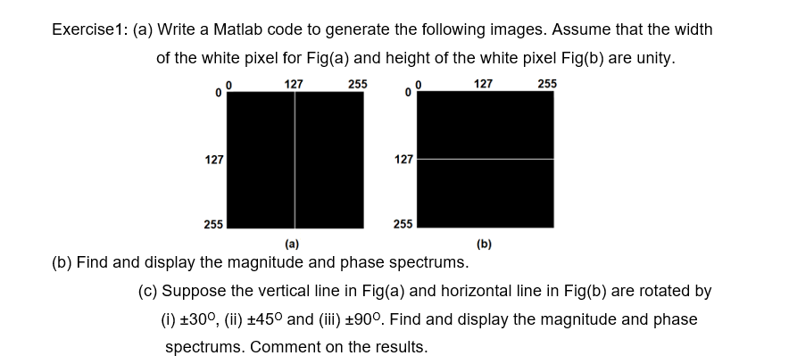

##### **CODE**

% x=zeros(255,255);

y=zeros(255,255);

y(127:128,1:255)=1

x(1:255,127:128)=1;

subplot(3,2,1);imshow(x);title('horizontal white line of height 1px');

subplot(3,2,2);imshow(y);title('vertical white line of width 1px');

fft\_x=fft2(x);

fft\_shift\_x=fftshift(fft\_x);

abs\_fft\_shift\_x=abs(fft\_shift\_x);

abs\_fft\_x=abs(fft\_x);

fft\_y=fft2(y);

fft\_shift\_y=fftshift(fft\_y);

abs\_fft\_shift\_y=abs(fft\_shift\_y);

abs\_fft\_y=abs(fft\_y);

subplot(3,2,3);imshow(abs\_fft\_x);title('horizontal mag spectrum without shift');

subplot(3,2,4);imshow(abs\_fft\_y);title('vertical mag spectrum without shift');

subplot(3,2,5);imshow(abs\_fft\_shift\_x);title('horizontal mag spectrum with shift');

subplot(3,2,6);imshow(abs\_fft\_shift\_y);title('vertical mag spectrum with shift');

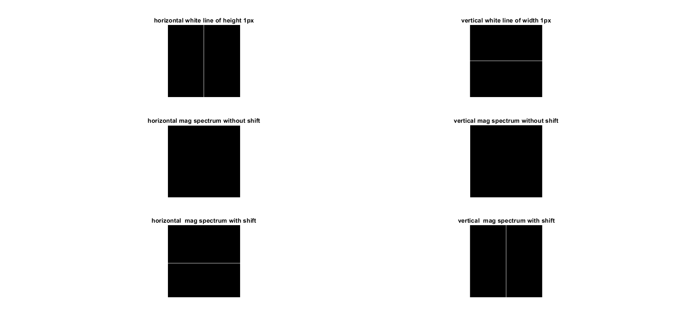

Figure 4: use of fft2( ) and fftshift( ) function in MATLAB

##### **CODE**

% %rotating the lines by 45 degree

x=zeros(255,255);

for i=1:255

for j=1:255

if j==i

x(i,j)=1;

end

end

end

fft\_x=fft2(x);

fft\_shift\_x=fftshift(fft\_x);

abs\_fft\_shift\_x=abs(fft\_shift\_x);

abs\_fft\_x=abs(fft\_x);

%rotating the lines by 30 degree

y=zeros(255,255);

for k=1:255

for l=1:255

if l==round(1.732\*k)

y(k,l)=1;

end

end

end

fft\_y=fft2(y);

fft\_shift\_y=fftshift(fft\_y);

abs\_fft\_shift\_y=abs(fft\_shift\_y);

abs\_fft\_y=abs(fft\_y);

subplot(2,3,1);imshow(x);title('rotated by 45 ');

subplot(2,3,2);imshow(abs\_fft\_x);title('fft of 45 ');

subplot(2,3,3);imshow(abs\_fft\_shift\_x);title('fft shift of 45 ');

subplot(2,3,4);imshow(y);title('rotated by 30 ');

subplot(2,3,5);imshow(abs\_fft\_y);title('fft of 30 ');

subplot(2,3,6);imshow(abs\_fft\_shift\_y);title('fft shift of 30 ');

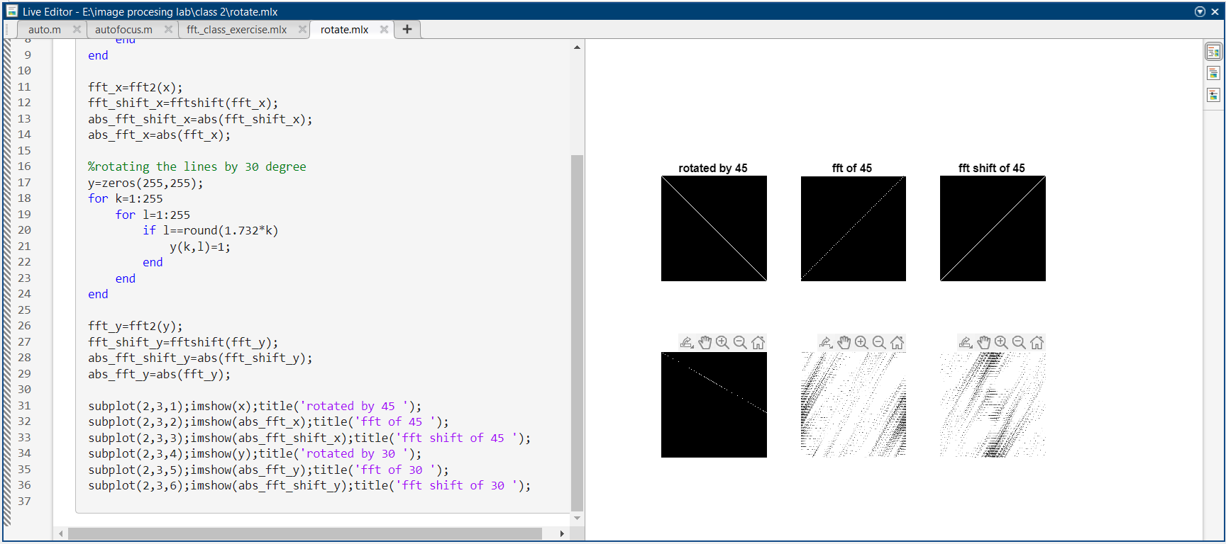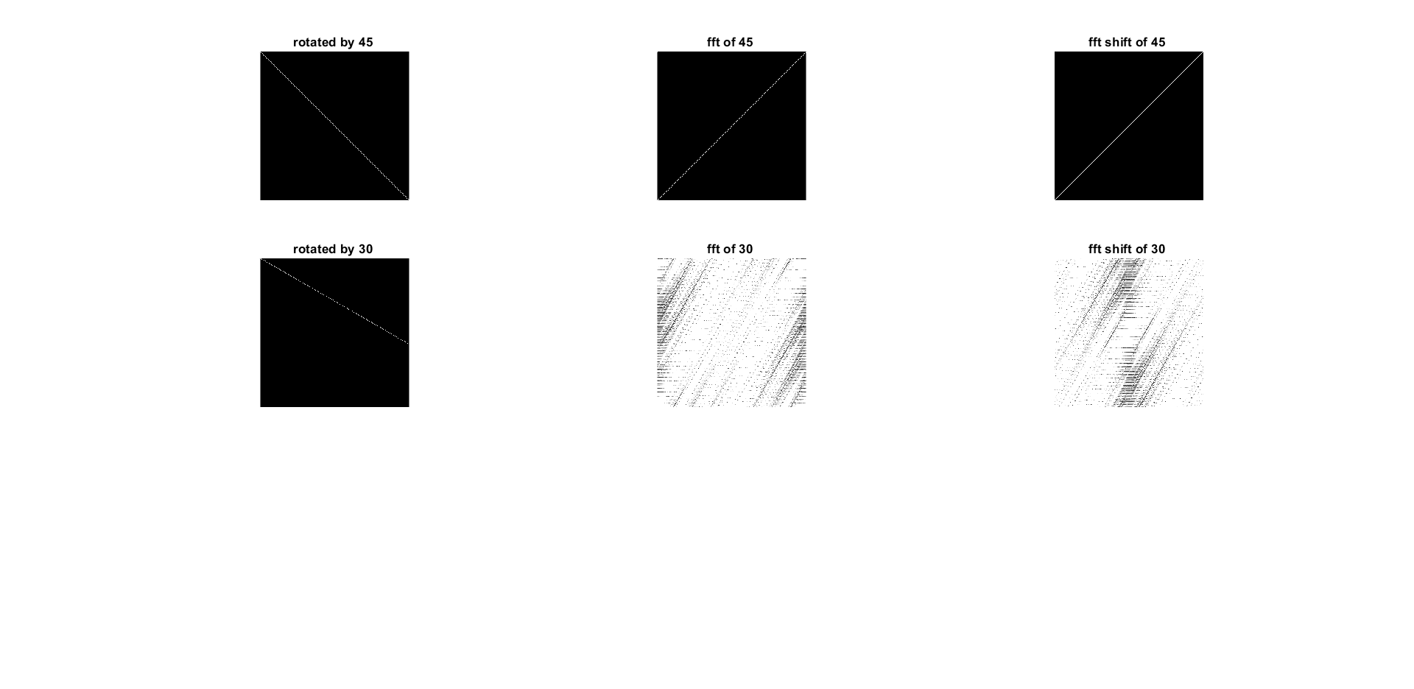

Figure 5: use of fft2( ) and fftshift( ) function in MATLAB

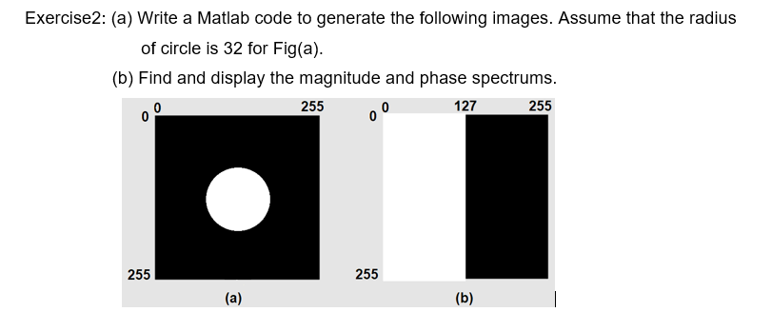

##### **CODE**

x x=zeros(255,255);

for i=1:255

for j=1:127

x(i,j)=1;

end

end

fft\_x=fft2(x);

fft\_shift\_x=fftshift(fft\_x);

abs\_fft\_shift\_x=abs(fft\_shift\_x);

abs\_fft\_x=abs(fft\_x);

r=32;x\_c=0;y\_c=0;

[y,x]=ndgrid(-127:128,-127:128);

y= (x-x\_c).^2+(y-y\_c).^2 <= r^2;

fft\_y=fft2(y);

fft\_shift\_y=fftshift(fft\_y);

abs\_fft\_shift\_y=abs(fft\_shift\_y);

abs\_fft\_y=abs(fft\_y);

subplot(3,2,1);imshow(x);title('black and white rectangle');

subplot(3,2,2);imshow(y);title('circle of radius 32');

subplot(3,2,3);imshow(abs\_fft\_x);title('rectangle mag spectrum without shift');

subplot(3,2,4);imshow(abs\_fft\_y);title('circle mag spectrum without shift');

subplot(3,2,5);imshow(abs\_fft\_shift\_x);title('rectangle mag spectrum with shift');

subplot(3,2,6);imshow(abs\_fft\_shift\_y);title('circle mag spectrum with shift');

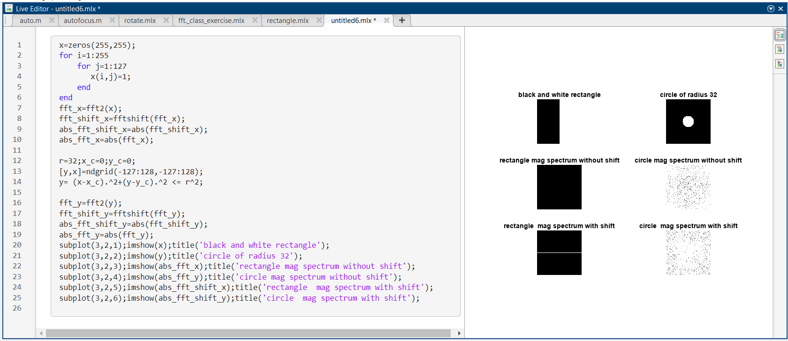

Figure 6: use of fft2( ) and fftshift( ) function in MATLAB

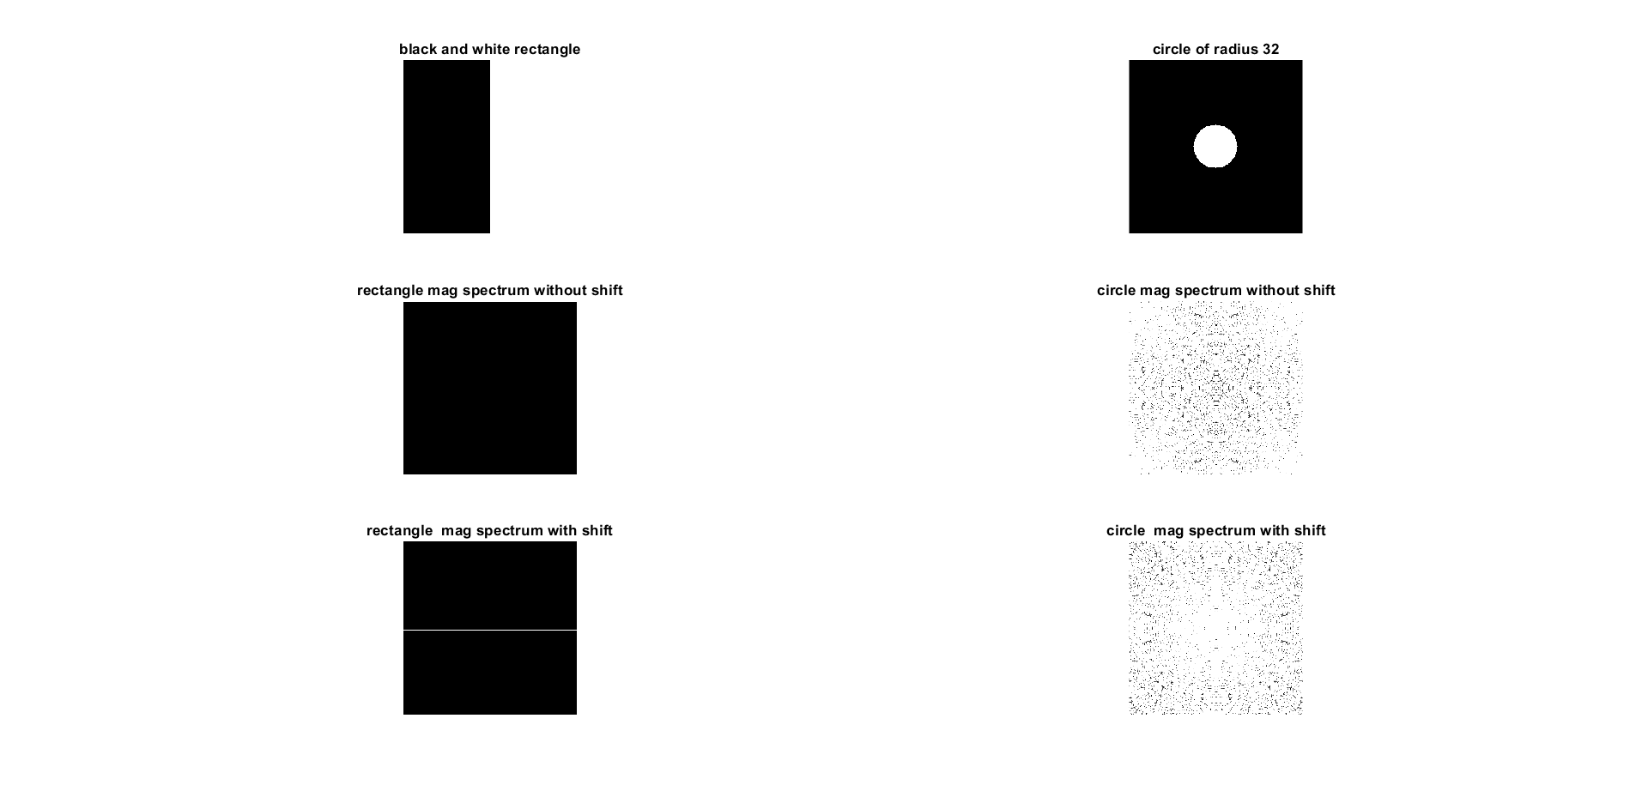

Figure 7: use of fft2( ) and fftshift( ) function in MATLAB

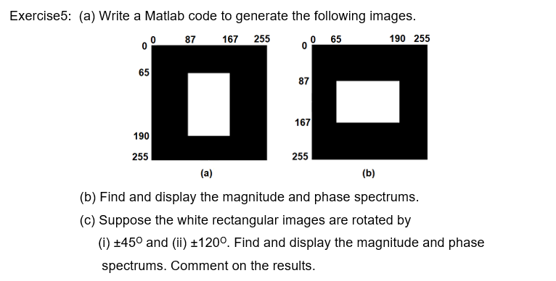

##### **CODE**

x=zeros(255,255);

y=zeros(255,255);

y(65:190,87:167)=1

x(87:167,65:190)=1

subplot(3,2,1);imshow(x);title('horizontal white line of height 1px');

subplot(3,2,2);imshow(y);title('vertical white line of width 1px');

fft\_x=fft2(x);

fft\_shift\_x=fftshift(fft\_x);

abs\_fft\_shift\_x=abs(fft\_shift\_x);

abs\_fft\_x=abs(fft\_x);

fft\_y=fft2(y);

fft\_shift\_y=fftshift(fft\_y);

abs\_fft\_shift\_y=abs(fft\_shift\_y);

abs\_fft\_y=abs(fft\_y);

%ploting all the images and there fft

subplot(3,2,3);imshow(abs\_fft\_x);title('horizontal mag spectrum without shift');

subplot(3,2,4);imshow(abs\_fft\_y);title('vertical mag spectrum without shift');

subplot(3,2,5);imshow(abs\_fft\_shift\_x);title('horizontal mag spectrum with shift');

subplot(3,2,6);imshow(abs\_fft\_shift\_y);title('vertical mag spectrum with shift');end

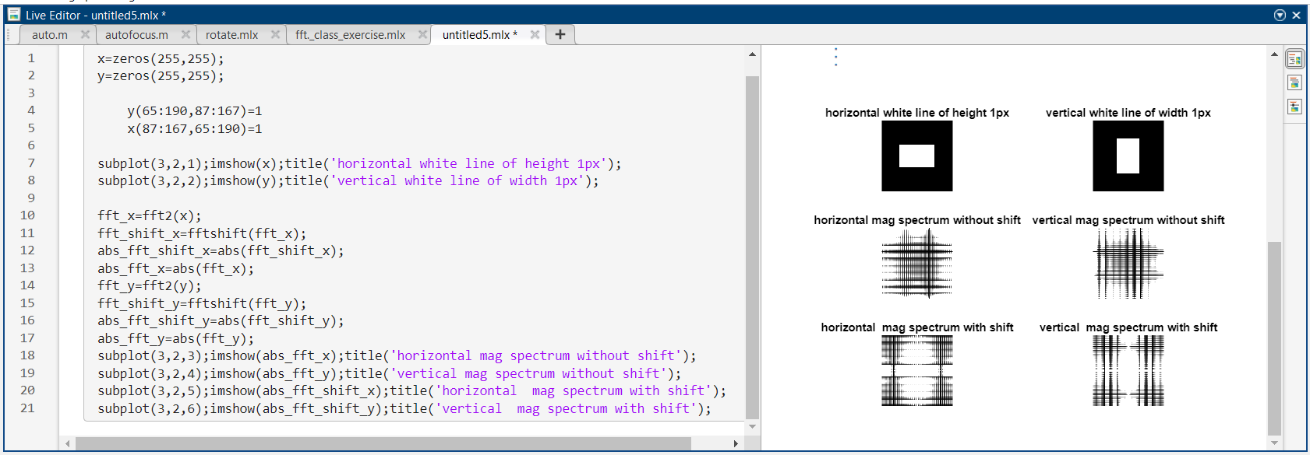

Figure 8: use of fft2( ) and fftshift( ) function in MATLAB

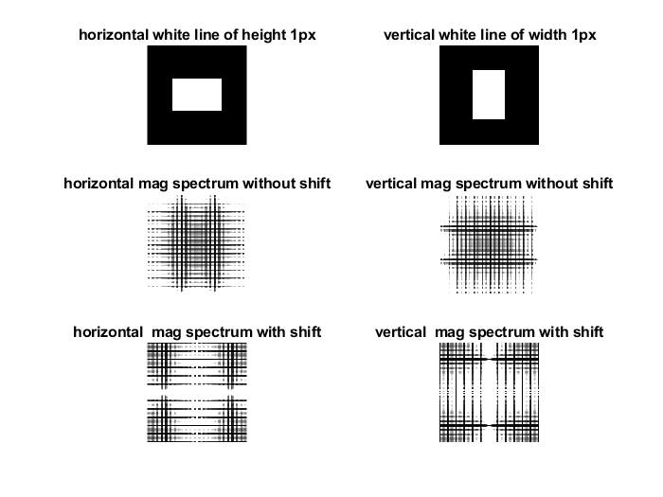

Figure 9: use of fft2( ) and fftshift( ) function in MATLAB

---------------------------------------------

Shreenandan Sahu |120BM0806